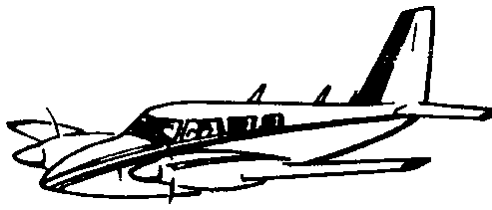
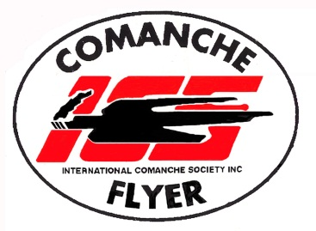
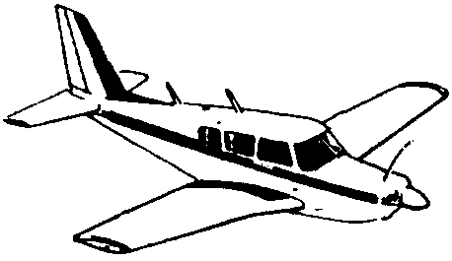

ABN 84 694 456 575
www.comancheflyer.com.au Secretary: Tony van der Spek
International Comanche Society - AUSTRALASIAN TRIBE

NOTICE OF GENERAL MEETING OF INTERNATIONAL COMANCHE SOCIETY
AUSTRALASIAN TRIBE

A General Meeting of the International Comanche Society – Australasian Tribe will take place at Narromine Airport Clubrooms at 2:40 pm on Saturday 25th October 2025.

AGENDA

Apologies

Declaration of proxies

Minutes of the last General meeting

Business arising from those minutes

Any other business

- Future for the ICS Australasian Tribe
- Future Fly-aways
- PPP Issues
- Any other business

Tony van der Spek
Secretary

02/10/25

