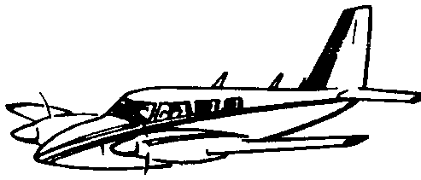
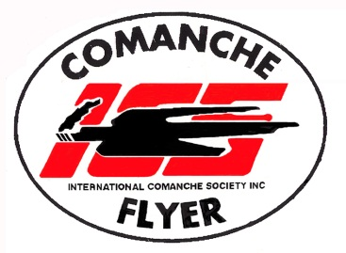
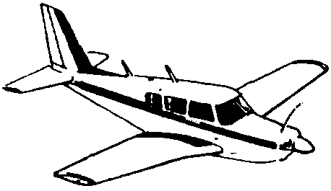

ABN 84 694 456 575
www.comancheflyer.com.au Secretary: Tony van der Spek
International Comanche Society - AUSTRALASIAN TRIBE

NOTICE OF ANNUAL GENERAL MEETING OF INTERNATIONAL COMANCHE SOCIETY
AUSTRALASIAN TRIBE

The Annual General Meeting of the International Comanche Society – Australasian Tribe will take place at the Narromine Airport Clubrooms at 2:00 pm on Saturday 25th October 2025 at 2.00pm..

AGENDA

Apologies

Declaration of proxies

Minutes of the last Annual General Meeting

Business arising from those minutes

Chief’s report

Treasurer’s report

Membership Report

Election of Office Bearers

Tony van der Spek
Secretary
02/10/25

